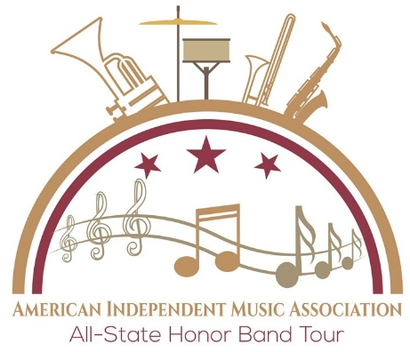

Dear ___________________________________

As a member of my school Band, I was recently nominated for the All-State Honor Band and invited to attend the American Independent Music Association Honor Band Tour in Pigeon Forge and Knoxville, Tennessee. I am thrilled to participate in this exciting event and perform with some of the best Band students from 6 states.

Our band will be in Tennessee from April 26-28, 2020, during which time we will take part in a rehearsals, sectionals, master classes, and time for some fun. Our schedule looks like this:
- Sun, 4/26: Band Rehearsal
- Mon, 4/27: Performances at the Pigeon Forge Children’s Home and “The Island”
- Tue, 4/28: Performance at a local Knoxville School

The event itself only costs $115, but with hotels, meals, transportation, and activities for myself and my chaperone, the total cost can be over $300. Would you be kind enough to make a contribution to my educational trip? I am asking those willing to generously donate any amount to help me make this happen. Although full sponsorship would be wonderful, it is not expected. Any assistance is greatly appreciated and places me closer to my goal of participating in the Honor Band Tour. I plan to share my photographs and experiences with contributors upon my return. Please feel free to contact me or the AIMA office if you need more information.

Thank you in advance for your consideration and support.

Sincerely yours,

How to help:
- Visit www.AIMAinfo.org.
- Click on the “Sponsorship” Button.
- 100% of your sponsorship will go to the student you designate.

